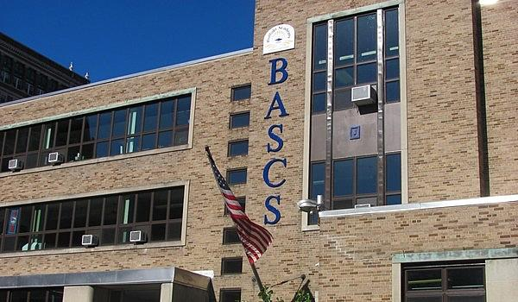

MINIMUM CAPACITY :-
The Minumum intake capacity
of students is between 150-350
children

LIBRARY :-
The Libarary is Available.

CANTEEN:-
The Canteen Facility is Available.

BOARDING :-
No availablility of boarding.

SPORTS :-
There are different categories
sports available.
Girls Volleyball
Boys Volleyball
Football

BUFFALO ACADEMY OF SCIENCE CHARTER SCHOOL
BUFFALO - SCHOOL

School Detail :-
The Buffalo Academy of Science Charter School (BuffSci) is a tuition-free, college preparatory charter school for grades Kindergarten through 12th. We are dedicated to providing quality education to a diverse body of students of Greater Buffalo in Western New York.
Buffalo Academy Of Science Charter School placed in the top 10% of all schools in New York for overall test scores (math proficiency is top 5%, and reading proficiency is top 20%) for the 2018-19 school year.
Minority enrollment is 86% of the student body (majority Black), which is higher than the New York state average of 57% (majority Hispanic and Black).
The percentage of students achieving proficiency in math is ≥95% (which is higher than the New York state average of 54%) for the 2018-19 school year. The percentage of students achieving proficiency in reading/language arts is 90-94% (which is higher than the New York state average of 52%) for the 2018-19 school year.

